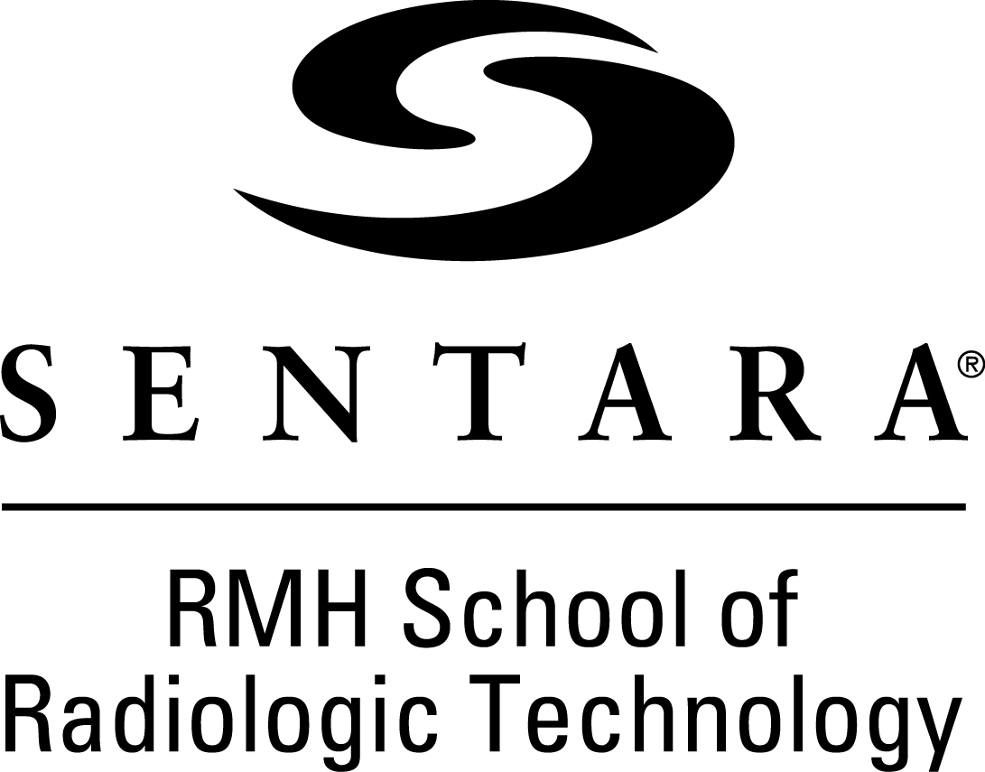

Admission Requirements

The ARRT requirement for eligibility to take the national registry examination is the completion of an Associate’s Degree or higher.
Program Prerequisites
Prerequisite for admission to the Sentara RMH School of Radiologic Technology is an Associate’s (or more advanced) degree in any field.

The applicant must have completed or enrolled in the following prerequisites or equivalent before applying:
- Anatomy and Physiology I (BIO 141) within the last 5 years
- Two (2) additional prerequisites
  - In addition to A&P I, the applicant must have completed or enrolled in at least 2 additional pre-requisite courses for the program before applying (listed below).

All of the following pre-requisites or equivalent must be completed prior to entering the program:
- Anatomy and Physiology II (BIO 142) within the last 5 years
- English Composition (ENG 111 or higher)
- College Level Math (MTH 154 or higher)
- Medical Terminology (HLT 143)
- Interactions Course (Ethics, Psychology, OR Sociology)
(PHI 220, PSY 200, or SOC 200 or higher)
***Any substituted courses are at the discretion of the Program Director and must be approved.

Satisfactory grades of “C” or higher must have been achieved in each of the pre-requisite courses.

An applicant must also have a cumulative 2.5 GPA or higher.

It is strongly suggested that the applicant participate in a job shadowing opportunity to more fully understand the field of Radiology and the commitment needed to pursue this rigorous program.

Application Process
Submitting the Application:
- Submit a completed application form to the Sentara RMH School of Radiologic Technology by December 1. A $25.00 non-refundable application fee must accompany the application.
Send transcripts from high school, and from all colleges previously attended, plus 3 reference forms to:
Sentara RMH Medical Center
School of Radiologic Technology
2010 Health Campus Drive
Harrisonburg, VA 22801

- When the application is complete and transcripts and references have been received, the applicant’s file will be evaluated. Those applicants meeting the admission requirements will be contacted to schedule an interview. (Application to the school does not guarantee admission)
- Decisions for admission to the program are based on a point system. Applicants are scored on academic achievements, tour/shadowing experience of Radiology, oral and written communication, prerequisites, health care experience and other criteria found on the Entrance scoring sheet.
- Applicants who have met all steps of the admission procedure and completed an interview with the school will be notified of their acceptance or regret regarding entry into the program in writing. A maximum of fifteen students are accepted into the school each year due to the limit placed on the number of students who can be at each of the clinical facilities.

Acceptance
Once a candidate is selected to attend the School of Radiologic Technology:

- The applicant must confirm their intention to enroll in writing. An orientation schedule will be sent to the student.
- The student attends a scheduled orientation meeting.
- A student’s acceptance into the program is conditional based on passing a physical examination (including drug/alcohol testing before acceptance and can be performed at any time during the program), criminal background check, CPR certification must be done by American Heart Association (adult, child, infant and AED for two years), and successful completion of any required prerequisite college courses and degree before entering the program. Failure to meet any of the requirements will result in termination of the student. Students will be responsible for all associated costs.
- Meet the standards for technical functioning. These standards have been developed to define the physical conditions necessary for a technologist to function in the health care environment. This level of functioning must be maintained throughout the program. The school reserves the right to require student testing as it deems appropriate to meet these physical demands. The Sentara RMH School of Radiologic Technology will make reasonable accommodation whenever possible.
Upon successful completion of the program, the graduate is eligible to take the American Registry of Radiologic Technologists examination leading to certification as a Registered Radiographer. In most states a valid state license is also required as a condition of employment. In Virginia, the graduate will apply to the Virginia Department of Health Professions to obtain a license upon passing the ARRT examination. Graduates are responsible for all costs.
The Sentara RMH School of Radiologic Technology has been accredited by the Joint Review Committee on Education in Radiologic Technology (www.jrcert.org) since 1966 and is certified to operate in the Commonwealth of Virginia by the State Council of Higher Education (www.SCHEV.edu). The JRCERT requires that all students complete the program within 150% of their original admission date, which means the student may only re-apply to the program one time, and it must be within a year of the original enrollment date.
Selection of students is made without discrimination against any individual or group of individuals on the basis of age, color, disability, gender, national origin, race, religion, sexual orientation, veteran status, genetic information or any other legally protected status.

